Monitoring Trout in the Town projects

Why Monitor?
This document explains our proposed approaches to monitoring Trout in the Town (TINTT) projects. Before moving on to define what can be assessed and the methods for doing so, it is worth setting out why resources should be allocated to monitoring at all. It is also worth noting that the protection of existing good conditions by sustainable means is just as important as generating new high quality habitat in a previously degraded system.
At the most basic (and bluntest!) level, monitoring tells practitioners whether their restoration works have had the desired effect(s). In the absence of any pre and post-project records or measurements; there is literally no indication of whether all the hard work has been worthwhile. In all cases (and especially for volunteer work forces), great satisfaction can be gained from the certain knowledge that habitat works have had a positive effect. Similarly, measurements of project success also demonstrate what has been achieved with monies donated by funding bodies. This is a very important consideration when seeking future funding from both existing and new funding partners. Clear demonstrations of what is likely to be achieved using benefactors’ money can be crucial in securing financial support for conservation projects.
Perhaps most importantly of all, monitoring the effects of specific interventions that aim to improve habitats would help to build an evidence base for “best practice” techniques. Continuing to develop such an evidence base will aid the propagation of good practices; whilst curtailing the use of poor practice. In this way, benefits that have been demonstrated on monitored projects can subsequently be achieved through wider applications of the proven techniques. The following sections set out our proposed strategy for the monitoring of TINTT projects.

How can effective monitoring be established?

General principles
Probably the most important aspect of establishing successful monitoring is the requirement to set out exactly what the work is trying to achieve. The setting of specific goals for restoration projects should be carried out for all planned activities. Without defined goals, assessment of whether they have been achieved cannot, of course, be carried out. Along with the planning of restoration goals, time needs (ideally) to be allocated to establishing pre-project assessments well before the onset of restoration work. In some cases, this could include the collation of existing information as well as/instead of taking empirical measurements. Naturally, provision should also be made for comparable post-restoration assessments. The idealised situation would include assessment that is undertaken on a timescale that matches any expected lag before benefits appear for each goal.
In the special case of setting goals for biological effects (see “Categories of effects to be monitored”), the most robust cases will be where there are clearly identifiable aspects of the habitat that are outside particular niche¹ requirements, e.g. absence of juvenile habitat for trout. In this example, the ultimate restoration goal would be the creation of juvenile habitat to complement existing good quality spawning and adult habitat. The goal should ideally specify a desired quantity of such habitat in order to assess the degree of achievement. Guidance on how to deal with setting goals where it is not possible to derive quantitative levels of desired improvement is offered in the section “Communicating results of monitoring assessments”.
Manipulating habitat that is already within niche requirements may have unpredictable effects ². Therefore, habitat assessments must prioritise the identification of those conditions that are outside niche limits. This allows obvious strangleholds to be systematically released using a suite of appropriate goals.

Categories of effects to be monitored
Two main categories of effects resulting from habitat conservation projects are suggested in the current scheme:
- Direct (physical)
- Consequential
Consequential effects are divided into further sub-categories:
  - Biological
  - Sociological
Here we define Direct effects as the simple physical result of each restoration activity. For example, a restoration goal could be to create 20-m² of spawning habitat to relieve a habitat bottleneck in recruitment. The Direct benefit to the system would be measured as the proportion of the proposed 20-m² gravel riffle that actually resulted from habitat works. Whereas, the Consequential Biological benefits could be expressed as the number of spawning redds observed within the reach before and after restoration work. This flags up the potential for tiered assessments of Consequential benefits – since each biological consequence could potentially have many additional ramifications. The extent to which ecological ramifications are monitored will, of course, depend on the resources available to each project (Appendix 1 gives an example). Similarly, Consequential Sociological benefits are likely to be many and varied. Again, tiered measurements ranging from simple assessments (e.g. the rate of fly-tipping pre and post-restoration or the uptake of youth angling coaching) through to sophisticated professional surveys of multiple community-level benefits should be considered. Suggested example methodologies for monitoring particular categories of effects are given in the following section.

Proposed methods for each category

Direct
The monitoring of direct benefits will generally only require fairly simple measures. For example, fixed point photography of reaches that are subjected to habitat works and/or trash clearances would be required as a minimum. An equally simple measure would be a formal record of planned versus completed works (including quantities and dimensions).

Consequential (Biological)
A minimum desired requirement (except in cases of population restoration) for fishery monitoring should be angler catch return data. Data should be collected using a scheme that records lengths of individual fish and duration of fishing (for an example proforma, see WTT document “Prioritising projects for Trout in the Town”). The recording of both angler effort (time fished) and differentiated size-classes for fish captured gives an indication of relative success of age-class specific restoration measures. An additional (more quantitative and more expensive) option for assessing fish populations would, of course, be formal electric fishing surveys carried out by trained personnel.
Another desirable in-stream assessment is invertebrate population monitoring. Again, this could be undertaken on a tiered basis according to resources. The basic monitoring should conform to the methodology and training provided by the Riverfly partnership³. The example recording sheets suggested for Trout in the Town (WTT document “Prioritising projects for Trout in the Town) can easily be translated into the Riverfly partnership formats as required. These basic-level monitoring methods will indicate the presence of a generally healthy invertebrate community over time – and will flag up the effects of pollution. However, if project personnel are able to identify invertebrates to the taxonomic level of Family, then further valuable information can be obtained.
A potentially very useful application of family-level (or even species-level) data would be to monitor the “LIFE” scores⁴ of restored streams. The acronym LIFE stands for “Lotic invertebrate Index for Flow Evaluation” and is a ranking of the requirement of invertebrate species and families for strong current flow. When there is a restoration goal to increase the variety of flow and depth; monitoring the overall LIFE score for the community and the abundance of selected high-scoring species or families is highly desirable. This, in conjunction with fishery data, will potentially provide very powerful evidence of habitat intervention leading to tangible ecological benefits.
Total LIFE scores and abundance of selected high-scoring LIFE taxa in a restored reach should always be compared to a closely neighbouring “reference” reach that has not received habitat interventions. It must be noted whether the reference reach is of low quality (i.e. equivalent to the pre-restoration condition of restored site) or high quality (a site that has a good variety of depth and flow). Contemporaneous sampling enables LIFE score in restoration sites to be expressed as a proportion of LIFE score in the reference site. It would be possible to express the percentage difference (in overall LIFE score and/or abundance of selected high scoring taxa) from a low quality reference site. Alternatively, percentage change in scores between “pre-project (restored site ÷high quality reference)” and “post project (restored site ÷high quality reference)” would be equally useful.
N.B. – TINTT would give guidance on the location of monitoring sites and would also analyse the resultant data. All that is required of project volunteers is the collection and identification of invertebrates (to the highest level of taxonomic resolution that volunteers can achieve)
In addition to the monitoring of in-stream biological consequences of restoration; riparian community responses should also be considered. This is especially true in cases where control/eradication of invasive plant species is undertaken. Surveying, mapping and photographing the extent of invasive plant domination before, during and after control programmes are recommended (and would count as a Direct benefit). Where additional resource and expertise is available, formal River Habitat Surveys (RHS⁵) and/or surveys of river corridor plants and animals can be carried out to assess Consequential benefits. In some cases, such surveys may already be routinely carried out as part of other conservation/wildlife initiatives. Efforts should be made to establish the existence of routine in-stream and riparian surveys.
Finally, as an example that ties together riparian and in-stream ecology, recording the consequences of tree-canopy management to tackle overshading should concentrate on both aquatic and terrestrial habitats. Naturally, both aquatic and terrestrial consequences should be assessed for all habitat management activities that are reasonably expected to substantially influence both environments. In such cases, it would be desirable to incorporate fixed point photography as well as formal surveys for mid-channel macrophytes such as Ranunculus spp. At the same time, surveys of understory vegetation and animals would be valuable additional demonstrations of wider biodiversity benefits to river restoration work. For aquatic and terrestrial vegetation, percentage cover data for identified varieties would be a useful metric. For terrestrial vertebrates and invertebrates, simple “sighting” data (presence/absence) may be the realistic limit of resolution that surveys can achieve – unless specialised resources and personnel are available. Finally, in cases where habitat works are designed to improve ecology by promoting geomorphological processes (e.g. localised scour), the depth profile should be measured at low flow along one or more cross-sections of channel. Carrying this out at a scale appropriate to installed structures (50-cm intervals along each cross section would be a useful rule of thumb) pre and post works will indicate whether habitat structure has been effectively influenced.

Consequential (Sociological)
As with baseline direct effects, fixed point photography detailing pre and post-project fly tipping is a very useful record. In addition, qualitative estimates of social use of river corridor (e.g. for staff lunches or walkers) provide indications that the urban green space is valued by local communities. More quantitative measures of social impact may include records of ”offered versus accepted” instances of classroom or community engagement initiatives.
For each community engagement or education programme, some means of generating satisfaction feedback should be incorporated and recorded (e.g. simple questionnaire). Especially with targeted participation activities such as working parties, river festivals and youth angling coaching; informal interview of participants could be a valuable means of assessment. Conversational assessment to establish alternative activities that participants have forgone in favour of Trout in the Town participation are likely to be particularly useful in this respect.
Where suitable resources and working partnerships exist, these basic assessments could be supplemented by professional assessment of community impact. For example, the not-for-profit organisation “SUBSTANCE” has recently won substantial funding to assess the social benefits of participation in angling. It is intended that all TINTT projects will receive questionnaires from the SUBSTANCE group for completion.

Communicating the results of monitoring assessments
It is recommended that the most concise and readily interpreted format for communicating project monitoring will be the “profiling” approach that is used to characterise ecosystem goods and services⁶. Profiling involves plotting the achieved degree of a particular restoration goal as a proportion of the desirable value. Using the example of the goal to create a 20-m² spawning riffle: if financial or legal (e.g. land drainage) constraints meant that this was limited to a 10-m² riffle – then this would yield a 50% satisfaction of that specific restoration goal. The full range of restoration goals should be arrayed on the x axis of each project profile. The percentage of each goal that has been attained can then be plotted against the y-axis (e.g. Fig.1). For clarity, it may be desirable to prepare three separate profiles; one each for Direct (physical), Consequential (biological) and Consequential (sociological) categories.
In some instances it will not be possible to produce adequate quantitative estimates of desired goals. For example, if the aim is to “increase abundance of high-scoring LIFE taxa”; it is only realistic to specify the direction of improvement. It is not possible to predict the magnitude of such changes. Therefore, “absolute percentage change” should be plotted – but clearly annotated to indicate that these do not relate to a specified desirable level.
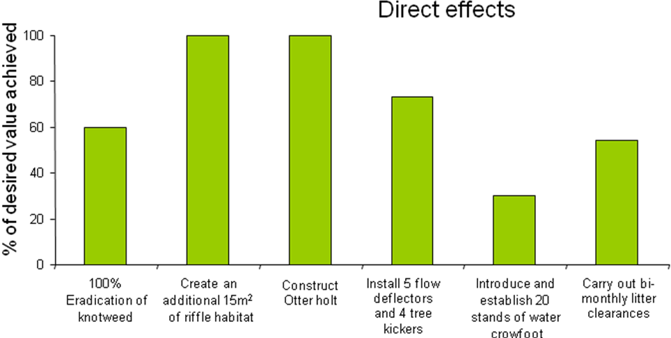
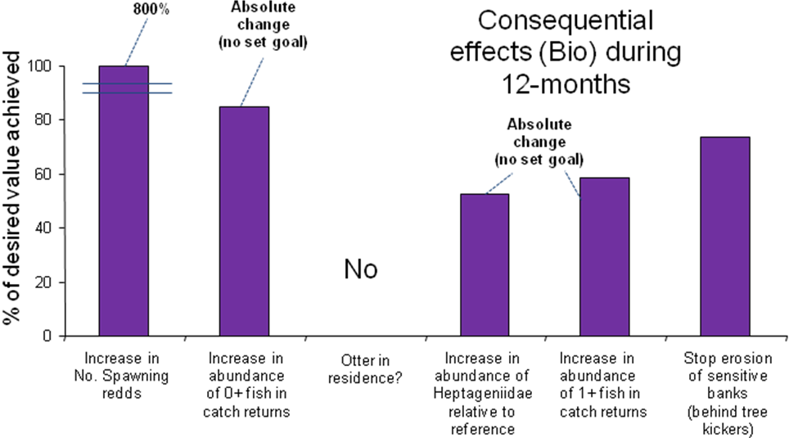
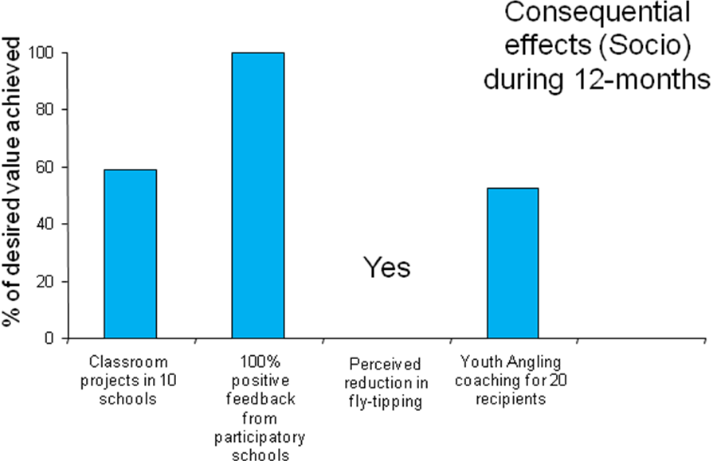
Figure 1: Profiling plots for Direct, Consequential (biological) and Consequential (sociological) benefits against specific goals
There will also be cases where it is not appropriate to plot percentage changes. Where restoration goals include encouraging or establishing the presence of a species that is initially absent; then the difference between presence and absence is a binary (all or nothing) condition. Again, profile plots should be annotated to make clear where goals include binary quantities. One method of doing this would be to replace plotted bars with “YES” or “NO” against the appropriate x-axis label (Fig. 1).

Summary of TINTT project monitoring process
- All projects must IDENTIFY and SET goals for their restoration activities (with TINTT programme manager advice)
- Undertake the mandatory and optional measures according to available project resources and delivery partner support (Table 1)
- Feed data back to TINTT programme manager for collation

Table 1: Mandatory and optional assessments of project benefits
 |  | Direct effects | Consequential effects
 |  | Direct effects | Biological | Sociological
Habitat works | Mandatory | - Assessment of planned versus executed works  - Fixed-point photographic record | Catch return records (when project involves an angling club) | SUBSTANCE questionnaires (where available)
Habitat works | Optional | Monitor local/national media coverage | - Riparian and aquatic flora/fauna (formal surveys or qualitative sightings records)  - Invertebrate monitoring to :  - Riverfly methodology  - Full family/species level | Canvassing of public using project green space
Trash cleanups | Mandatory | Planned versus executed programme |  | SUBSTANCE questionnaires (where available)
Trash cleanups | Optional | Monitor local/national media coverage |  | Canvassing of public perception & fly-tipping rates
Community & educational schemes & events | Mandatory | Self-assessment of goal attainment (aims met? To what degree?) |  | Canvassing of participants and SUBSTANCE questionnaires (where available)
Community & educational schemes & events | Optional | Monitor local/national media coverage |  | Environmental careers uptake c.f. regional average

Footnotes and citations
- At its simplest a niche is the set of conditions and resources needed by an individual (or species) in order to practice its way of life (after Hutchinson, G. E. (1957). "Concluding remarks, Cold Spring Harbor Symposium." Quant. Biol, 22, 415-427
- Armstrong, J.D ., Kemp, P.S., Kennedy, G.J.A., Ladle, M. and Milner, N.J. (2003). “Habitat requirements of Atlantic salmon and brown trout in rivers and streams” Fisheries Research, 62, 143–170
- http://www.riverflies.org/index/riverfly_monit.html
- Extence, C.A., Balbi, D.M. and Chadd, R.P.(1999) “River Flow Indexing Using British Benthic Macroinvertebrates: A Framework for Setting Hydroecological Objectives” Regulated Rivers: Research & Management, 15, 543–574
- http://www.environment-agency.gov.uk/homeandleisure/wildlife/31374.aspx
- Maltby, L; Paetzold, A and Warren, P (in review) “Sustaining industrial activity and ecological quality: the potential role of an ecosystem services approach.”, Ecology of Industrial Pollution: Remediation, Restoration and Preservation, Blackwells

Appendix 1: Example application and interpretation of monitoring programme (biological information)

